import { Component } from '@angular/core';

@Component({

selector: 'app-root',

templateUrl: './app.component.html',

styleUrls: ['./app.component.css']

})

export class AppComponent {

//title = 'app';

private name:string;

private Phone:string;

}

Parent.ts

<h1>I am Parent Component</h1>

<div>

EnterName <input type="text" placeholder="EnterName" [(ngModel)]="name"><br><br>

EnterPhone <input type="text" placeholder="EnterPhone" [(ngModel)]="Phone">

</div>

<div>

<app-child parentnamevalue="{{name}}"

parentphonevalue="{{Phone}}"></app-child>

</div>

Parent.html

import { Component, OnInit,Input } from '@angular/core';

@Component({

selector: 'app-child',

templateUrl: './child.component.html',

styleUrls: ['./child.component.css']

})

export class ChildComponent implements OnInit {

constructor() { }

ngOnInit() {

}

@Input() parentnamevalue="";

@Input() parentphonevalue="";

}

Child.ts

<p>

child works!

</p>

<h1>Retriving the parent data to child component</h1>

<div>

Getting Name= {{parentnamevalue}}<br><br>

Getting Phone= {{parentphonevalue}}

</div>

Child.html

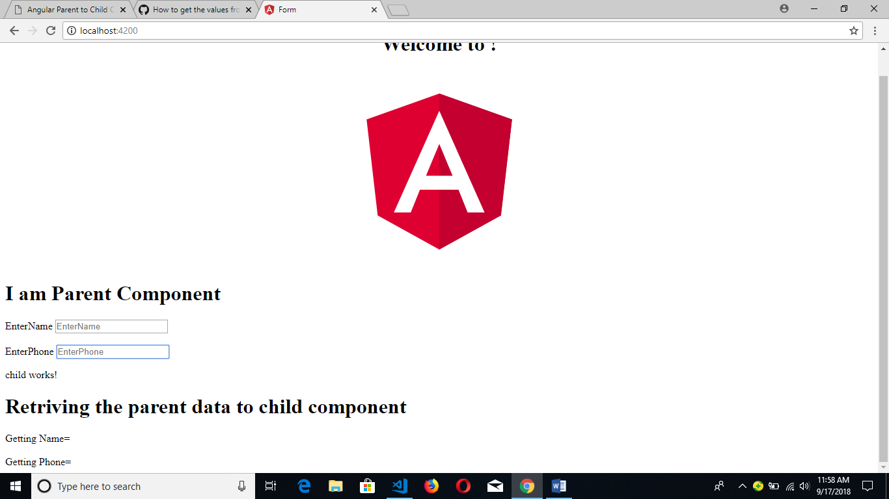

This is initial stage.

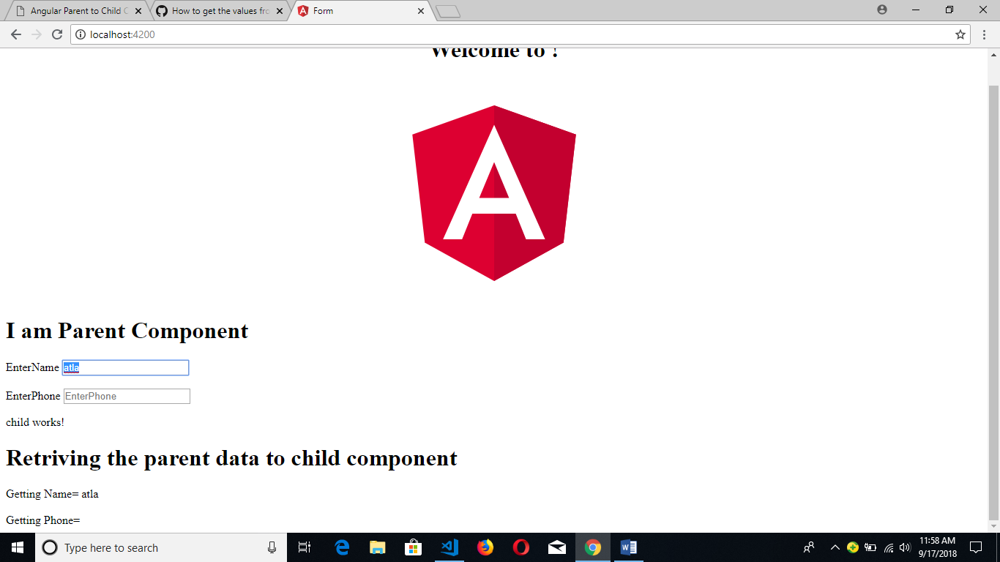

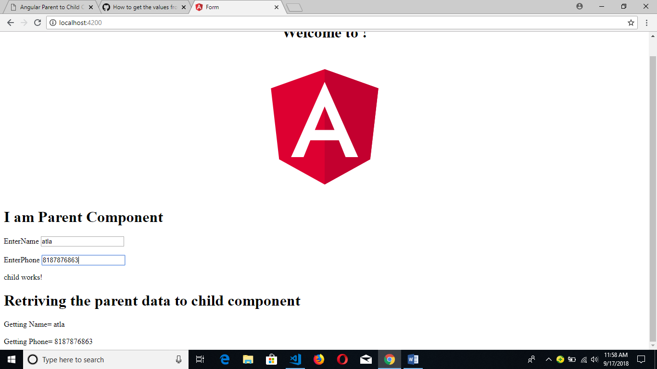second stage

And here perform two way data binding.